GULISTAN & TURGUT OZAL EDUCATIONAL INSTITUTIONS
INFORMATICS LESSON PLAN

DATE :
DURATION : | 40 minutes
GRADE LEVEL: | 10th Class
SUBJECT : | Using Built-in Functions 1
OBJECTIVES : | To learn how to use predefined Excel functions

LESSON PLAN
Key words:
Materials used: | Microsoft Excel 2003 Book, Computer
Warm-up questions:

Introduction and explanation of the lesson;
SIMPLE FUNCTIONS: SUM, AVERAGE, COUNT, MAX, MIN
Excel provides a wide range of predefined functions.
You will study in this section some basic functions and their uses, and the way to access these functions.
If you click on the small arrow next to the AutoSum button on the Standard toolbar and then select More functions (or if you select Function from the Insert menu), you will see the Insert Function window.
There are three main parts in this window. If you remember the function name write it in the Search for a function box. If you know the function name and category for sure, you can first select the category 1 and then select the function from the Select a function list box 2 . Below the list box 3 , a brief usage and explanation is shown. There is also a link for help 4 for the current function at the bottom left corner of the dialog box.
1 SUM FUNCTION
This function calculates the sum of the numbers within the range. Any cell that is not a number format will be ignored. For the Sum function you can write single cell addresses with commas or you can also use a colon(:) to define a range.
Example 5.4:
If your Excel worksheet contains the data shown in Figure 5.8, the following formulas give the results described in the table below.
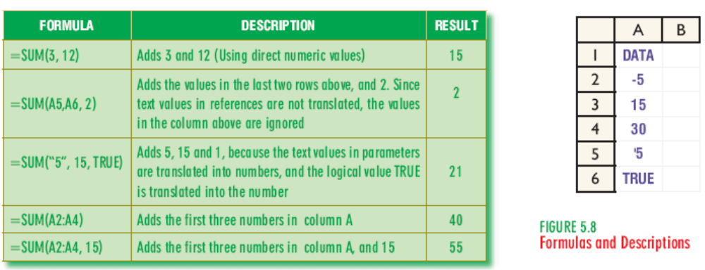
CONCLUSION:

HOMEWORK:

Teacher Director

